Mahatma Education Society's
PILLAI COLLEGE OF ARTS, COMMERCE & SCIENCE

(Autonomous)
Re-accredited “A” Grade by NAAC (3rd Cycle)

Project Completion Certificate

THIS IS TO CERTIFY THAT
Prapti Pramod Ghodekar

Of FY AIML has completed the project titled
“Snake Game Using Linked List (Deque and Queue) with GUI in Python”
Under our guidance and supervision during the academic year 2025-26 in the department of Artificial Intelligence and Machine Learning

Project Guide course coordinator


MAHATMA EDUCATION SOCIETY’S

PILLAI COLLEGE OF ARTS, COMMERCE & SCIENCE
(Autonomous)

NEW PANVEL

PROJECT REPORT ON
“Snake Game Using Linked List (Deque and Queue) with GUI in Python ”

IN PARTIAL FULFILLMENT OF
BACHELOR OF SCIENCE
SEMESTER II – 2025-26
PROJECT GUIDE
Name: Prajakta Kane
SUBMITTED BY: Prapti P. Ghodekar
ROLL NO: 1765

Sample Evaluation sheet for continuous assessment with rubrics

Class: FY AIML
Subject: Data Structure Fundamental using python

Details about the continuous Assessment 2/Project work
Name of Evaluator: Prajakta Kane
Roll no: 1765
Class / Division: FY B.Sc. AI/ML
Name of Evaluator: Prof. Prajakta kane

Please circle appropriate score
Grading Criteria | Fair | Good | Excellent | Total
Introduction/ Description of the Case
SWOT Analysis of the company used for case analysis pertaining to the case
Learnings from the case
Delivery/presentation skills
Total

- Inform the class the rubric format and the method of evaluation.

1. Project Title Template

Snake Game Using Linked List (Deque and Queue) with GUI in Python
The project titled “Design and Implementation of a Snake Game Using Linked List (Deque and Queue) with Tkinter GUI in Python” focuses on developing a classic snake game using Python. The application utilizes the deque data structure to represent a linked list, enabling efficient insertion and deletion operations required for snake movement. A graphical user interface is created using the Tkinter library, allowing real-time interaction through keyboard controls. The project demonstrates the practical application of queue and linked list concepts, event-driven programming, and GUI design, making it an effective learning tool for understanding data structures in an interactive environment.

Technology Used:
- Programming Language: Python
- GUI Library: Tkinter
- Data Structures: Linked List (Deque), Queue
- Additional Libraries: random, collections.deque

2. Synopsis
The Snake Game Using Linked List (Deque and Queue) with GUI is a classic arcade-style game developed using Python’s Tkinter library. The project demonstrates the practical application of data structures, especially linked lists implemented through deque, to manage the snake’s movement efficiently.
In this game, the snake moves continuously on a graphical window and grows in length each time it consumes food. The snake’s body is stored using a deque, allowing fast insertion at the head and deletion at the tail, which perfectly matches the snake’s movement logic. The game ends when the snake collides with the wall or itself.
This project helps in understanding:
- GUI programming using Tkinter
- Implementation of linked lists using deque
- Event handling and keyboard controls
- Real-time game updates using timers

3. Program

Description of the Program
- The game window is created using Tkinter.
- The snake body is represented using a deque, acting as a linked list.
- The snake’s head is inserted at the front (appendleft) and the tail is removed (pop) to simulate movement.
- A queue-like behavior is observed when managing snake growth.
- Keyboard arrow keys control the snake’s direction.
- Collision detection handles wall hits and self-collision.
- The game can be restarted by pressing R after Game Over.

Key Components Used
- Canvas: To draw the snake and food
- deque: To manage the snake body efficiently
- after(): For continuous movement updates
- bind(): To capture keyboard inputs

Program code: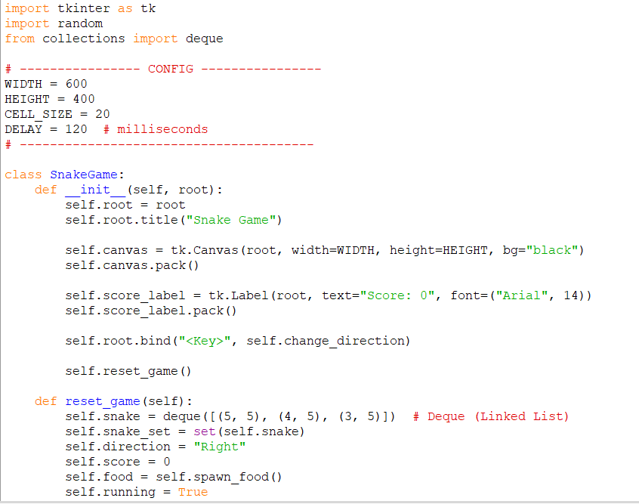
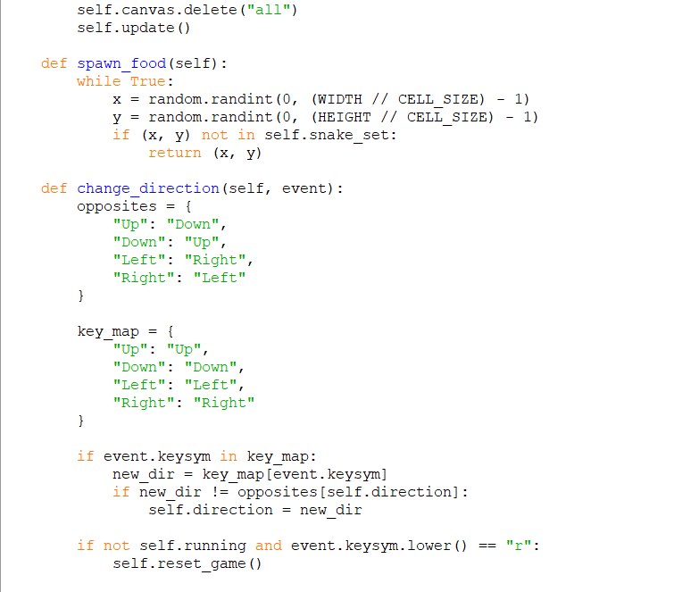

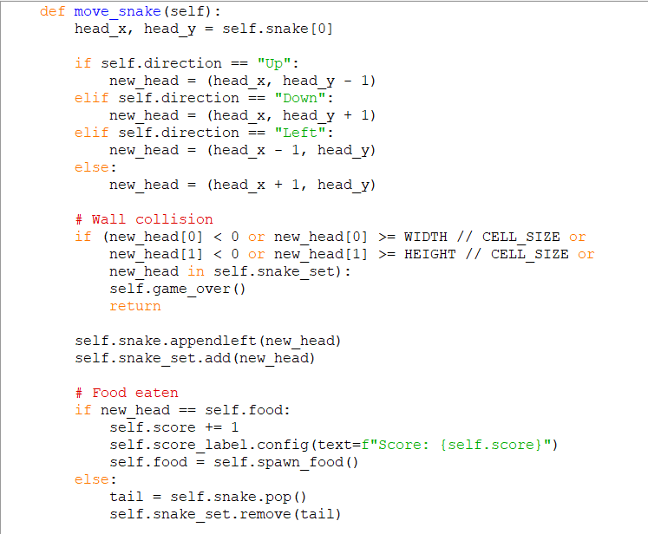

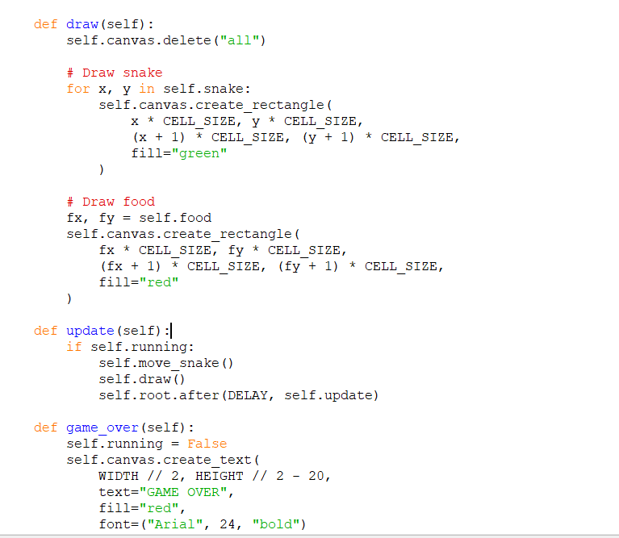

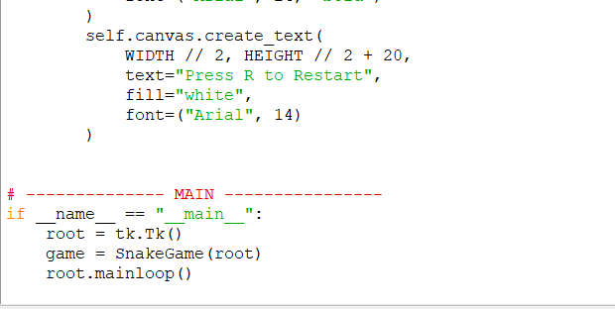

4. Output Snapshots (Description)

Output 1: Game Start Screen
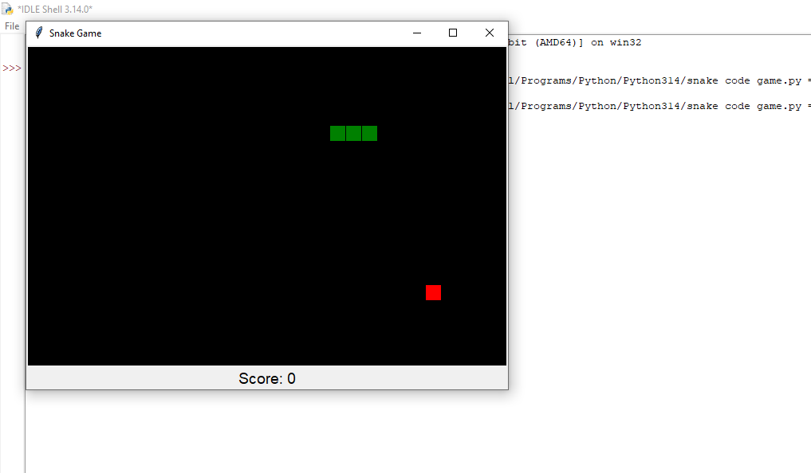

Output 2: Snake Movement and Food Consumption
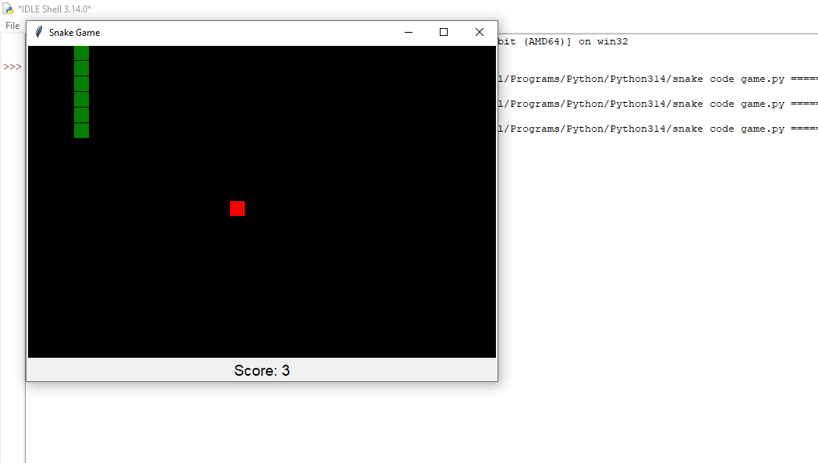

Output 3: Game over Screen and Restart again after clicking R

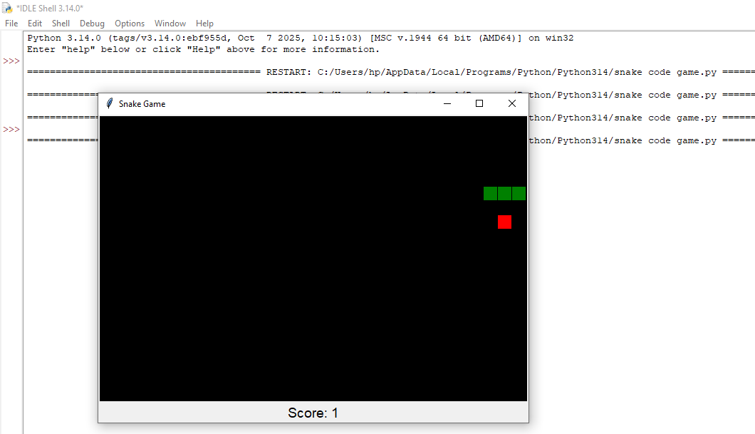

Conclusion
The Snake Game project successfully demonstrates the use of linked list concepts implemented through deque and queue in a real-time application. By integrating Python Tkinter GUI, the project provides an interactive and user-friendly gaming experience. It enhances understanding of data structures, event handling, and graphical programming, making it an effective and practical learning project.

